# Dissertation Testing

**ResNet Baseline**

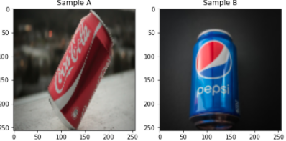Total params – 2,855,362

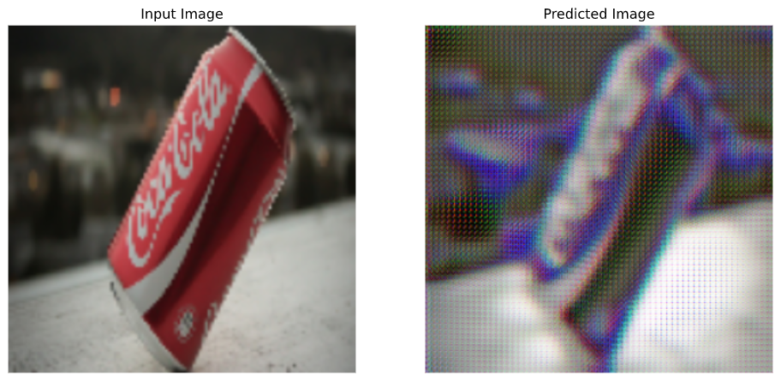Time taken for epoch 1 is 74.7829077243805 sec

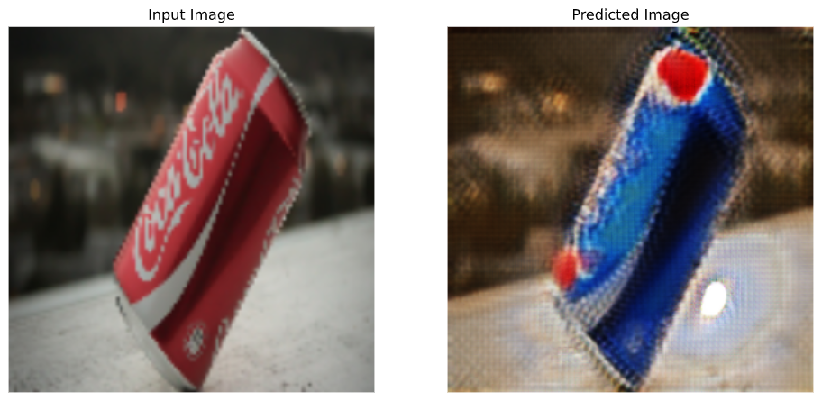Time taken for epoch 40 is 69.37611365318298 sec

|  |  |  |
| --- | --- | --- |
| Epoch | Time | Total Cycle Loss (Mae) |
| 5 |  |  |
| 10 |  |  |
| 20 |  |  |
| 30 |  |  |
| 40 |  |  |